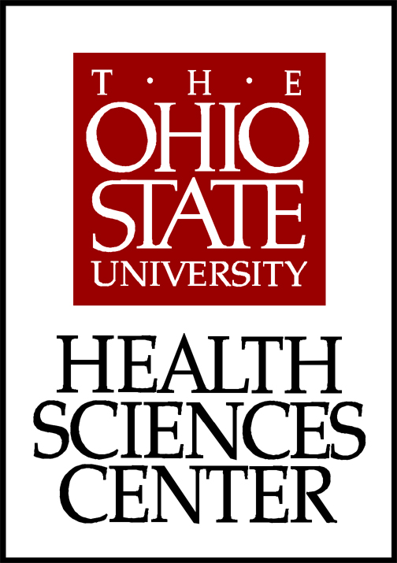
Medical Dietetics Division
School of Allied Medical Professions
The Ohio State University
453 West Tenth Avenue
306 Atwell Hall
Columbus, Ohio 43210-1234

November 2, 2006

Dear Subcommittee B of the Committee on Curriculum and Instruction,

Thank you for allowing me to explain that the course I submitted earlier this quarter, EDU P&L 411, Body, Brain, and Learning, was intended to be part of a two course sequence. Hopefully, this sequence will be part of an undergraduate Minor called, “Integrative Approaches to Health and Wellness”. This Minor is slated to be voted on this quarter by CAA. I am attaching a copy of the advising sheet that will be used when the minor is approved, so that you can see that the logical sequence would be for students to take the core course in the Minor: Allied Med 307, the Evolving Art and Science of Medicine, (which is already a GEC), followed by EDU P&L 411, Body, Brain, and Learning. My intent was to have at least two of the courses offered in the minor be GEC’s. I want students to be able to take a series of GEC’s that might lead to a minor.

The first course, The Evolving Art and Science of Medicine traces the history of medicine and medical education, looking at scientific medicine as a socio/cultural product. This is a great course to teach, and hopefully a worthwhile one to take as it examines the development of both medicine and the resulting doctor/patient relationship. This course helps both medical provider and patient (which we will all eventually fall under one of those categories) examine how the past events in the history of scientific medicine has sculpted the relationship that we know today as “doctor/patient”. The purpose of this course is that both medical provider and patient come to understand how their role evolved, and where it might go. I have attached a syllabus of this GEC.
The course that I have submitted for your approval, EDU P&L 411, Brain, Body and Learning, examines the history of American education as socio/cultural product, with the Cartesian separation of mind and body being salient in its development. I want students to understand how education itself has impacted how they view themselves. We read “The Education of Little Tree” to highlight the role that assimilation has played in American education, and examine current brain research that shows the influence that denying our heritage has on our development and how it impacts the view of self. This too is also a wonderful course to teach as it pertains not just to the history of education, but exposes students to utilizing movement (the body) to help in their own learning. So, they take away not just lessons we can get from history, but some practical suggestions of how to utilize the current literature on brain research for themselves as learner.

This sequence could be worthwhile for students of many different disciplines. All students will occupy the role of “patient” and all students already occupy the role of “student”. This sequence examines the development of both of these roles, and will be able to count towards the minor (upon approval) “Integrative Approaches to Health and Wellness”.
The director of the Curriculum Office, Jessica Mercerhill, has offered to send the request for concurrence to the Department of History, while EDU P&L 411, Body, Brain, and Learning, is in your committee.

Thank you for your consideration, and I would be happy to come in and meet with your committee upon request, or answer any questions you may have.

Sincerely,

Maryanna D. Klatt, PhD
Assistant Professor of Clinical Allied Medicine
Visiting Assistant Professor, College of Education
306G Atwell Hall
453 W. 10th Avenue
Columbus, Ohio 43210
Phone: (614)-292-0065
Fax: (614)-292-0210
E-mail: Maryanna.Klatt@osumc.edu

